Array Based Binary Tree
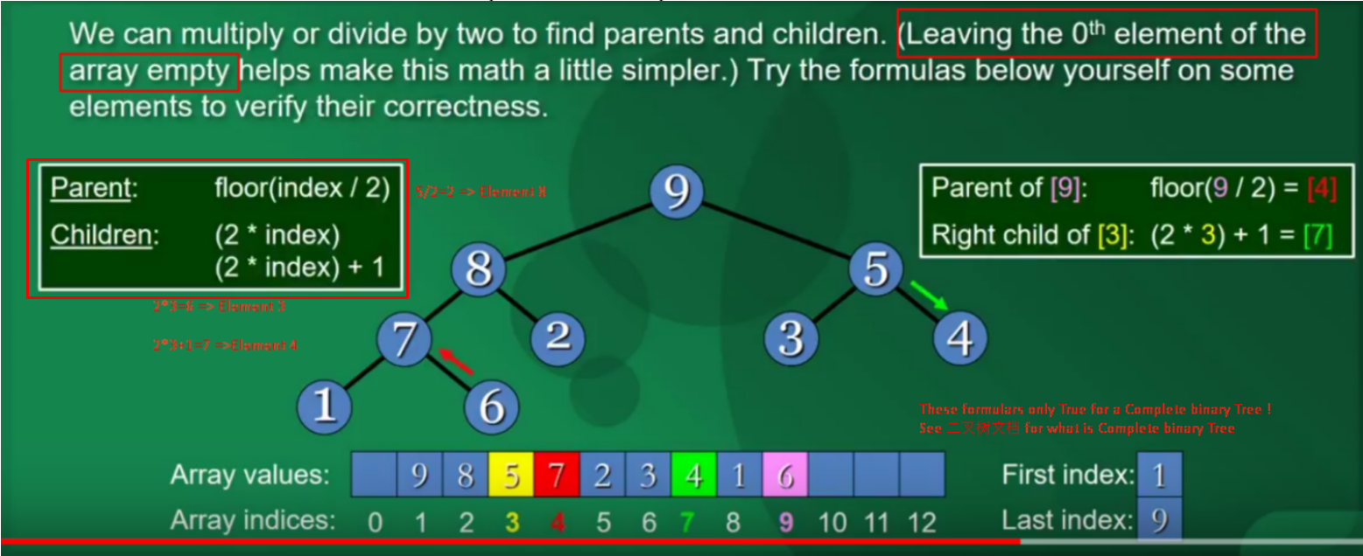

- we use Arraylist data structure to store Array based binary tree but not the tree structure.

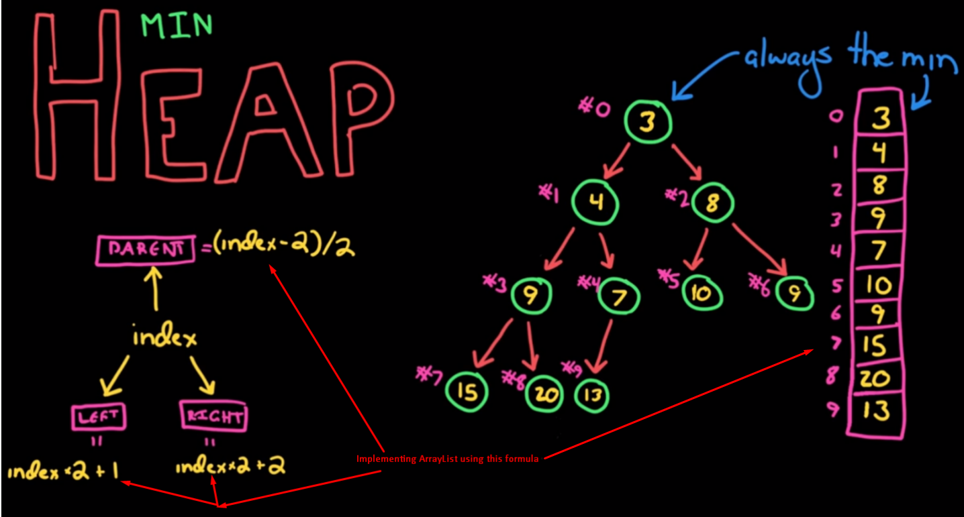

-heaps 分为maximum 和minimum heap.
maximum heap : parent node always have greater value than child note.
minimum heap : the opposite .

-heaps don’t have to be right subtree greater than left subtree , unlike binary search tree

Insert and deletion from a array based binary tree/heapify
- for inserting : insert to the next empty leaf node position(from left to right) and compare it with it’s parent node , if greater then swap
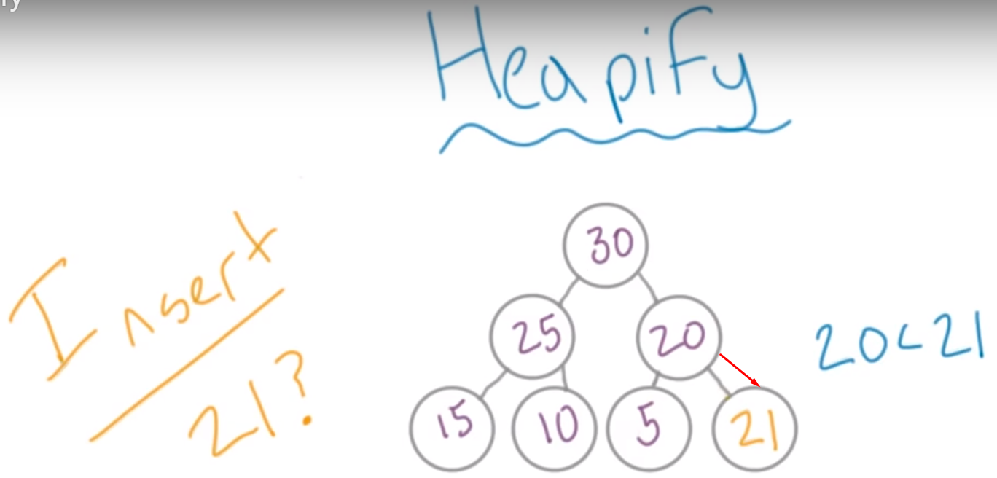

- for deleting : delete the top element and filled by most right leaf node and compare it with it’s sub-node, if it’s lesser then swap.
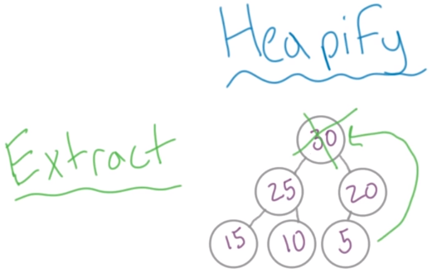

- time complexity
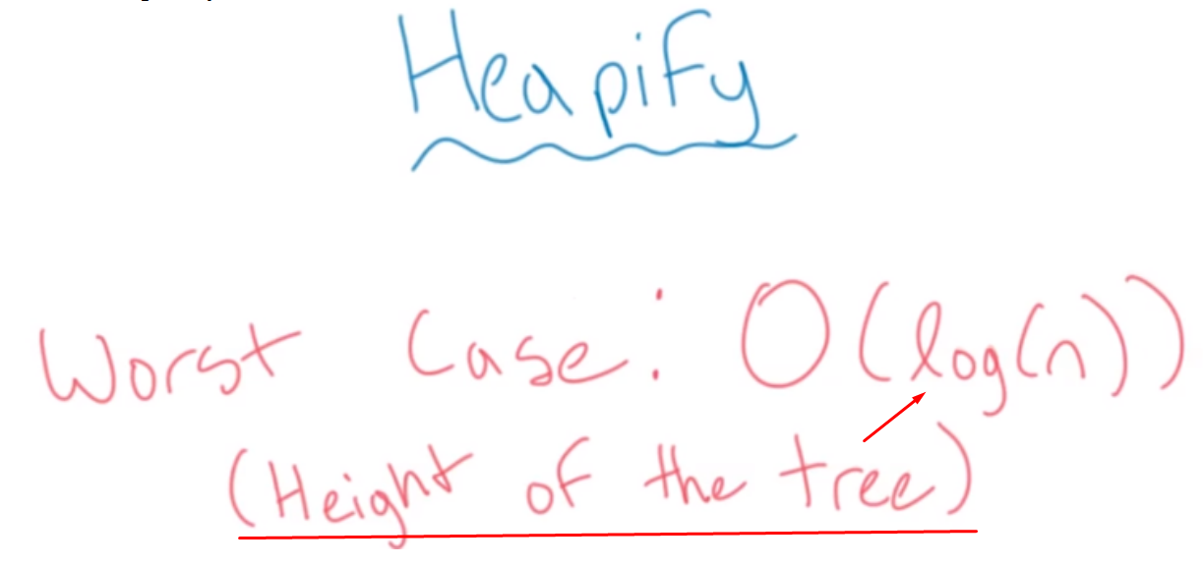
Rules of array based binary tree
